A000-Afr-Congo DR-N’kisi-Statue-Female-Wood-19th c

***Note:******The Democratic Republic of the Congo*** *has been known as, in chronological order, the Congo Free State, Belgian Congo, the Republic of Congo-Léopoldville, the Democratic Republic of the Congo and the Republic of Zaire, before returning to its current name the Democratic Republic of the Congo or, hereinafter, Congo DR.*

***Note: The Kongo people*** *(singular: Mukongo, pl. Bakongo) speak Kikongo, a Bantu language, who have lived along the Atlantic coast of Central Africa, in a region that, by the 15th century, was a centralized and well-organized Kongo Kingdom but is now a part of three countries: the Democratic Republic of the Congo, the Republic of the Congo and Angola.*

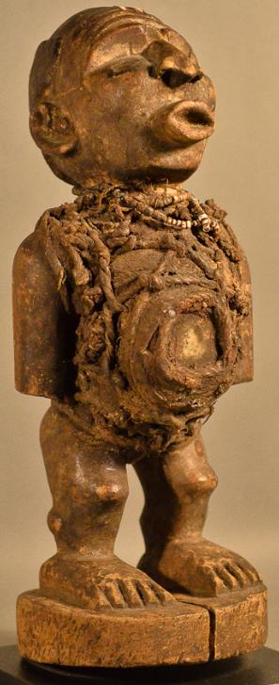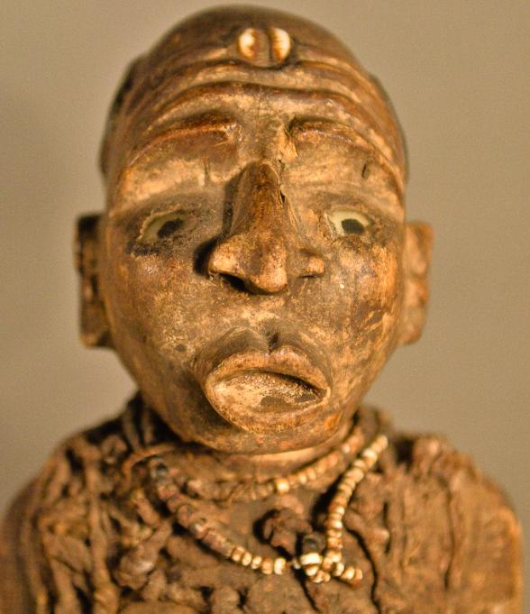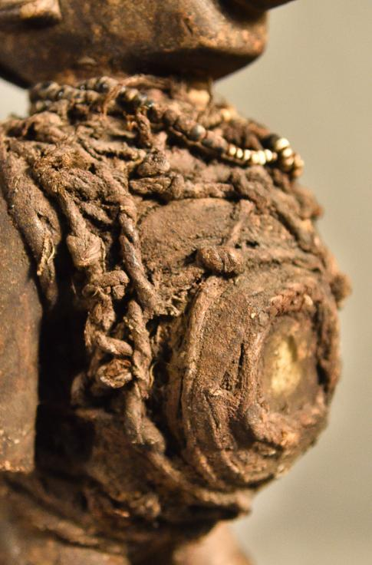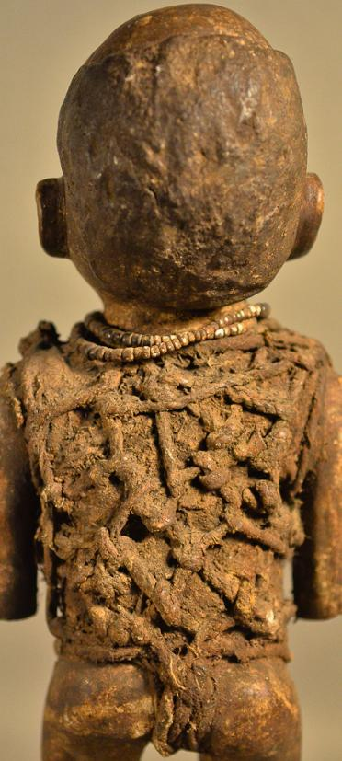

Figs. 1-4. Afr-Congo DR-N’kisi-Statue-Female-Wood-19th c

**Case no.: 6**

**Accession Number:**

**Formal Label:** Congo DR-N’kisi-Statue-Female-Wood-19th c

**Display Description:**

The N’kisi is a wooden sculpture in which inheres a spiritual being with the physical attributes of a woman shaman who is powerless until she has been activated by the need of a patient. This N’kisi has a classic Kongo face with expectant glass eyes and wrinkled brow (suggestive of the serious effort being exerted. Its forehead is adorned with a cowry shell which is shaped like the womb and therefore symbolic of successful childbirth (MacGaffey 1988:192). The cowry is "kodya" in the Kongo language, which evokes the word "kola", "to be strong." The exhortation of this powerful midwife to the mother-to-be, demonstrated by her protruding lips and everted nose indicating the need for labored breathing and bent knees suggestive of an advantageous child-bearing position. Pregnancy is also emphasized by a protruding belly that is covered with mysterious medicinal paraphernalia and divination objects -- wrappings of rope, roots and a leather pouch (which also contains other powerful but unseen, hence mysterious, objects such as efficacious insects and snake teeth). All of these unseen objects are affixed with secret types of knots securing these hidden objects with their mysterious powers to her body and by sympathetic magic to that of the patient. Her arms are at her side, showing attentiveness to the patient and are consistent with her well-carved ears suggesting that she is ready to hear entreaties. A small, beaded, white, shell necklace is encrusted with libations after years of use.

**LC Classification: NB1099.C6**

**Date or Time Horizon:** 19th c

**Geographical Area:** DR Congo

**Map:**

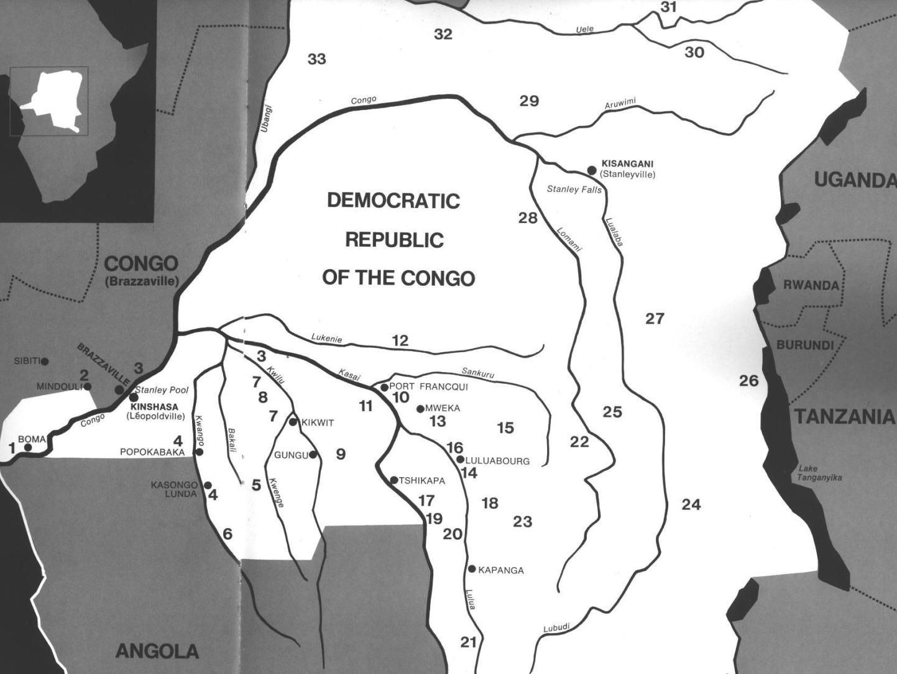

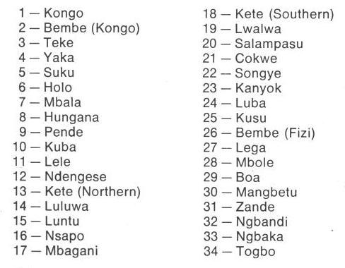

Fig. 1. Map of Kongo Cultures, West Central Africa. After Walker Art Center 1967.

**GPS coordinates:**

**Cultural Affiliation:** Kongo peoples.

**Media:** wood, raffia, shells,

**Dimensions:**

**Weight:**

**Condition: original**

**Provenance:** old Belgian collection, ca 1885.

**Discussion:**

In at least two impressive Royal locations the Kongo recognized the medical contributions of Pygmy lore by their own specialists: Mbanza Kongo and Loango. In order to incorporate pygmy expert medical knowledge into Kongo culture, Ntinu Lukeni married the daughter of a local pygmy spiritual leader, Manikabunga, established the town of Mpemba Kasi (near the modern village of Matadi in the Kwilu valley), where the original Kongo Kingdom rulers would be buried. Ntinu Lukeni initiated the tradition of using pygmy medicines (*bilongo*) in conjunction with the Kongo N’kisi with Manikabunga‘s and thus Kongo syncretic medical knowledge was achieved.

In addition this N’kisi sculpture of a woman shaman/healer is related to this effort of the Kongo to incorporate Pygmy medical knowledge into Kongo lore. Therefore, the current sculpture expresses this visually as Mbanza Kongo and Loango had transmitted this knowledge to Ntinu Lukeni who, through his Pygmy wife and her father Manikabunga were able to acquire knowledge of women’s health first-hand. Indeed, she may have been responsible for images such as this N’kisi.

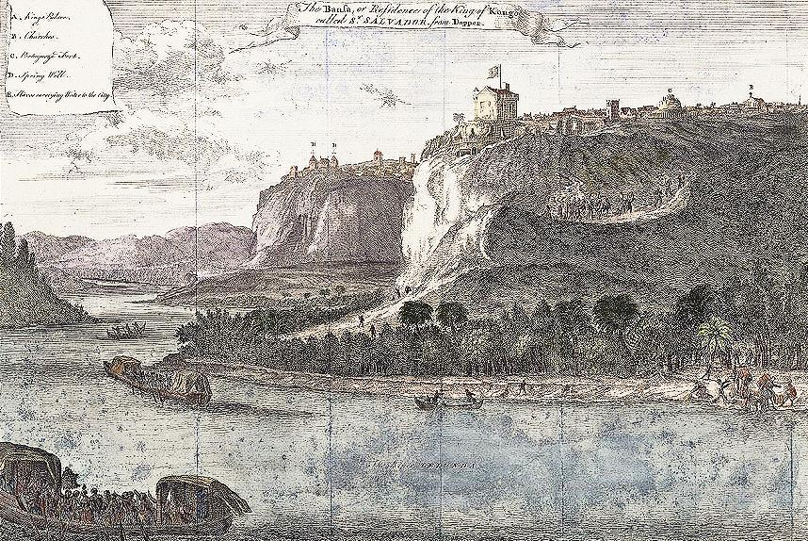

Fig. 10. Mbanza Kongo, “The Bansa or residence of the King of Kongo called Ste. Savadore [by the Portuguese] from Olfert Dapper, *Description de l’Afrique*  (Amsterdam: W. Waesberge, Boom et Van Someren, 1686), where the Kingdom’s medical specialists, *nganga* or *ngang’a n’kisi* gathered to assess and confirm local pygmy knowledge. The Nzadi or Congo River in the foreground shows two laden trade vessels.

**References:**

Adams, Monni. 1988. 8th century Kuba king figures, *African Art* 21(3): 32-38, 88.

Belepe, Bope. 1974. *Etude socio-morphologique des masques Bwoom des Kuba: Memoire de licence en histoire.* Lubumbashi: Université Nationale du Zaire.

Belepe, Bope. 1981. Les oeuvres plastiques Africaines comme documents d'histoire: Le cas des statues Royales Ndop des Kuba du Zaire, *Africa­Tervuren* 25(1): 9-17.

Binkley, D. 1987. Avatar of power: Southern Kuba masquerade figures in funerary context, *Africa* 57 (1).

Binkley, D. 1990. Masks, space and gender in southern Kuba initiation ritual, *Iowa Studies in Art.* Vol. 3, *Art and Initiation in Zaire.* Iowa City: The University of Iowa.

Brett-Smith, Sarah. 1983. “The Doyle Collection of African Art,” *Record of the Art Museum, Princeton University*, 42(2): 2+8-34.

Kuba du Zaire, Africa­ Tervuren 27(1): 9-17.

Binkley, D. 1987. Avatar of power: Southern Kuba masquerade figures in funerary context, *Africa* 57 (1).

Binkley, D. 1990. Masks, space and gender in southern Kuba initiation ritual, *Iowa Studies in Art.* Vol. 3, *Art and Initiation in Zaire.* Iowa City: The University of Iowa.

Claerhout, A. 1976. Two Kuba wrought-iron statuettes, *African Art* IX (4): 60-64.

Cornet, J. 1972. *Art de l'Afrique Noire au pays du fleuve Zaire*. Brussels: Arcade.

Cornet, J. 1975. *Art from Zaire: 100 Masterworks from the National Collection.* New York: African-American Institute.

Cornet, J. 1982. *Art royal Kuba.* Milan: Sipiel.

Ehret, Christopher. 2002. *The civilizations of Africa: a history to 1800*. Charlottesville: Virginia: University of Virginia Press.

Forbath, Peter. 1977. *The River Congo*. Boston: Houghton Mifflin.

Laman, Karl. 1953. *The Kongo*. 4. vols. Stockholm: Victor Pettersons.

MacGaffey, Wyatt. 1986. *Religion and society in central Africa: the Bakongo of Lower Zaire*. Chicago: University of Chicago Press.

MacGaffey, Wyatt. 1988. “Complexity, astonishment and power: the visual vocabulary of Kongo minkisi,” *Journal of African Studies*, (14:2), 188-203.

Martinez-Ruiz, Barbaro. 2013. *Kongo Graphic Writing and other Narratives of the Sign*. Philadelphia: Temple University Press.

Rosenwald, J. B. 1974. “Kuba king figure,” *African Art,* VII (3).

Schadeberg, Thilo. 1999. “Batwa: the Bantu name for the invisible people.” In *Challenging Elusiveness: Central-African Hunter Gatherers in a Multidisciplinary perspective*, ed. K. Beibrouck, S. Elders, and G. Rossel. Leiden: CNWS, 21-39.

Thompson, Robert Farris. 1978. “The Grand Detroit N’kondi,” *Bulletin of the Detroit Institute of Arts* 56 :4, 206-217.

Torday, E. and T. A. Joyce. 1911. « Notes ethno­graphiques sur les peuples communement appeles Bakuba, ainsi que sur les peuplades apparentees, les Bushoongo. » In *Annales du Musee Royal du Congo Belge, Ethnographie et Anthropologic.,* serie III, tome II, fasc. 1. Brussels: Tervuren.

Vansina, Jan. 1955 “Initiation Rituals of the Bushong,” *Africa* 25(2): 138-153.

Vansina, Jan. 1964. *Le royaume kuba.* Tervuren: Musée royal de l'Afrique centrale.

Vansina, Jan. 1978. *The children of Woot. A history of the Kuba peoples.* Madison: University of Wisconsin Press/Dawson.

Vansina, Jan. 1984. *Art History in Africa.* London: Longman.

Vansina, Jan M. 1990. [*Paths in the Rainforests: Toward a History of Political Tradition in Equatorial Africa*](https://books.google.com/books?id=6M8Wv0Tp8VwC)*.* Madison: University of Wisconsin Press.

Van Wing, Joseph Hubert Leopold. 1941. *Études Bakongo*. II. *Religion et magie*. Institut royal colonial belge. Section des sciences morales et politiques. Mémoires, collection in-8°, t. IX, fasc. 1. Brussels: Desclée de Brouwer.

Van Wing, Joseph Hubert Leopold. 1959. *Études Bakongo.* Brussels: Desclée de Brouwer.

Walker Art Center. 1967. *Art of the Congo*. Minneapolis: Walker Art Center.